Санкт-Петербургский национально исследовательский университет

информационных технологий, механики и оптики

Факультет программной инженерии и компьютерной техники



**Курсовая работа №1**

Вариант №63

Часть 1

Выполнил: Балтабаев Дамир Темиржанович

Группа: P3112

Преподаватель: Поляков Владимир Иванович

г. Санкт-Петербург

2020

f = 1 при 8<(1x4x5+x1x2x3)≤11

f = d при |x5x1x2-x4x3|=3

1. Составление таблицы истинности

|  |  |  |  |  |  |  |  |  |  |  |  |  |  |  |  |
| --- | --- | --- | --- | --- | --- | --- | --- | --- | --- | --- | --- | --- | --- | --- | --- |
| N | X1X2X3X4X5 | | | | | 1X4X5 | (1X4X5)10 | X1X2X3 | (X1X2X3) 10 | x5x1x2 | (x5x1x2)10 | x4x3 | (x4x3)10 | |-| | F |
| 0 | 0 | 0 | 0 | 0 | 0 | 100 | 4 | 000 | 0 | 000 | 0 | 00 | 0 | 0 | 0 |
| 1 | 0 | 0 | 0 | 0 | 1 | 101 | 5 | 000 | 0 | 100 | 4 | 00 | 0 | 4 | 0 |
| 2 | 0 | 0 | 0 | 1 | 0 | 110 | 6 | 000 | 0 | 000 | 0 | 10 | 2 | 2 | 0 |
| 3 | 0 | 0 | 0 | 1 | 1 | 111 | 7 | 000 | 0 | 100 | 4 | 10 | 2 | 2 | 0 |
| 4 | 0 | 0 | 1 | 0 | 0 | 100 | 4 | 001 | 1 | 000 | 0 | 01 | 1 | 1 | 0 |
| 5 | 0 | 0 | 1 | 0 | 1 | 101 | 5 | 001 | 1 | 100 | 4 | 01 | 1 | 3 | d |
| 6 | 0 | 0 | 1 | 1 | 0 | 110 | 6 | 001 | 1 | 000 | 0 | 11 | 3 | 3 | d |
| 7 | 0 | 0 | 1 | 1 | 1 | 111 | 7 | 001 | 1 | 100 | 4 | 11 | 3 | 1 | 0 |
| 8 | 0 | 1 | 0 | 0 | 0 | 100 | 4 | 010 | 2 | 001 | 1 | 00 | 0 | 1 | 0 |
| 9 | 0 | 1 | 0 | 0 | 1 | 101 | 5 | 010 | 2 | 101 | 5 | 00 | 0 | 5 | 0 |
| 10 | 0 | 1 | 0 | 1 | 0 | 110 | 6 | 010 | 2 | 001 | 1 | 10 | 2 | 1 | 0 |
| 11 | 0 | 1 | 0 | 1 | 1 | 111 | 7 | 010 | 2 | 101 | 5 | 10 | 2 | 3 | d |
| 12 | 0 | 1 | 1 | 0 | 0 | 100 | 4 | 011 | 3 | 001 | 1 | 01 | 1 | 0 | 0 |
| 13 | 0 | 1 | 1 | 0 | 1 | 101 | 5 | 011 | 3 | 101 | 5 | 01 | 1 | 4 | 0 |
| 14 | 0 | 1 | 1 | 1 | 0 | 110 | 6 | 011 | 3 | 001 | 1 | 11 | 3 | 2 | 1 |
| 15 | 0 | 1 | 1 | 1 | 1 | 111 | 7 | 011 | 3 | 101 | 5 | 11 | 3 | 2 | 1 |
| 16 | 1 | 0 | 0 | 0 | 0 | 100 | 4 | 100 | 4 | 010 | 2 | 00 | 0 | 2 | 0 |
| 17 | 1 | 0 | 0 | 0 | 1 | 101 | 5 | 100 | 4 | 110 | 6 | 00 | 0 | 6 | 1 |
| 18 | 1 | 0 | 0 | 1 | 0 | 110 | 6 | 100 | 4 | 010 | 2 | 10 | 2 | 0 | 1 |
| 19 | 1 | 0 | 0 | 1 | 1 | 111 | 7 | 100 | 4 | 110 | 6 | 10 | 2 | 4 | 1 |
| 20 | 1 | 0 | 1 | 0 | 0 | 100 | 4 | 101 | 5 | 010 | 2 | 01 | 1 | 1 | 1 |
| 21 | 1 | 0 | 1 | 0 | 1 | 101 | 5 | 101 | 5 | 110 | 6 | 01 | 1 | 5 | 1 |
| 22 | 1 | 0 | 1 | 1 | 0 | 110 | 6 | 101 | 5 | 010 | 2 | 11 | 3 | 1 | 1 |
| 23 | 1 | 0 | 1 | 1 | 1 | 111 | 7 | 101 | 5 | 110 | 6 | 11 | 3 | 3 | d |
| 24 | 1 | 1 | 0 | 0 | 0 | 100 | 4 | 110 | 6 | 011 | 3 | 00 | 0 | 3 | d |
| 25 | 1 | 1 | 0 | 0 | 1 | 101 | 5 | 110 | 6 | 111 | 7 | 00 | 0 | 7 | 1 |
| 26 | 1 | 1 | 0 | 1 | 0 | 110 | 6 | 110 | 6 | 011 | 3 | 10 | 2 | 1 | 0 |
| 27 | 1 | 1 | 0 | 1 | 1 | 111 | 7 | 110 | 6 | 111 | 7 | 10 | 2 | 5 | 0 |
| 28 | 1 | 1 | 1 | 0 | 0 | 100 | 4 | 111 | 7 | 011 | 3 | 01 | 1 | 2 | 1 |
| 29 | 1 | 1 | 1 | 0 | 1 | 101 | 5 | 111 | 7 | 111 | 7 | 01 | 1 | 6 | 0 |
| 30 | 1 | 1 | 1 | 1 | 0 | 110 | 6 | 111 | 7 | 011 | 3 | 11 | 3 | 0 | 0 |
| 31 | 1 | 1 | 1 | 1 | 1 | 111 | 7 | 111 | 7 | 111 | 7 | 11 | 3 | 4 | 0 |

2. Представление булевой функции в аналитическом виде

КДНФ: X1X2X3X4X5 ∨ X1X2X3X4X5  ∨ X1X2X3X4X5 ∨ X1X2X3X4X5 ∨ X1X2X3X4X5  ∨ X1X2X3X4X5 ∨ X1X2X3X4X5  ∨ X1X2X3X4X5  ∨ X1X2X3X4X5 ∨ X1X2X3X4X5

ККНФ: (X1∨X2∨X3∨X4∨X5) (X1∨X2∨X3∨X4∨X5) (X1∨X2∨X3∨X4∨X5) (X1∨X2∨X3∨X4∨X5)

(X1∨X2∨X3∨X4∨X5) (X1∨X2∨X3∨X4∨X5) (X1∨X2∨X3∨X4∨X5) (X1∨X2∨X3∨X4∨X5) (X1∨X2∨X3∨X4∨X5) (X1∨X2∨X3∨X4∨X5) (X1∨X2∨X3∨X4∨X5) (X1∨X2∨X3∨X4∨X5) (X1∨X2∨X3∨X4∨X5) (X1∨X2∨X3∨X4∨X5) (X1∨X2∨X3∨X4∨X5) (X1∨X2∨X3∨X4∨X5) (X1∨X2∨X3∨X4∨X5)

3. Найти МДНФ и/или МКНФ методом Квайна – Мак-Класки.

Нахождение простых импликант (максимальных кубов). Получение кубов различной размерности кубического комплекса K(f) и выделение из них простых импликант:

|  |  |  |  |  |  |  |  |  |  |  |  |
| --- | --- | --- | --- | --- | --- | --- | --- | --- | --- | --- | --- |
| **№** | **К0(f) V N (f)** | **√** | **№** | **К1(f)** |  | **√** | **№** | **К2(f)** |  | **№** | **Z(f)** |
| 1 | 00101 | √ | 1 | X0101 | 1-10 |  | 1 | 10XX1 | 6-15 | 1 | X0101 |
| 2 | 00110 | √ | 2 | 0X110 | 2-4 |  | 2 | 10X1X | 9-16 | 2 | 0X110 |
| 3 | 01011 | √ | 3 | X0110 | 2-11 |  | 3 | 101XX | 12-16 | 3 | X0110 |
| 4 | 01110 | √ | 4 | 01X11 | 3-5 |  |  |  |  | 4 | 01X11 |
| 5 | 01111 | √ | 5 | 0111X | 4-5 |  |  |  |  | 5 | 0111X |
| 6 | 10001 | √ | 6 | 100X1 | 6-8 | √ |  |  |  | 6 | 1X001 |
| 7 | 10010 | √ | 7 | 10X01 | 6-10 | √ |  |  |  | 7 | 1X100 |
| 8 | 10011 | √ | 8 | 1X001 | 6-14 |  |  |  |  | 8 | 1100X |
| 9 | 10100 | √ | 9 | 1001X | 7-8 | √ |  |  |  | 9 | 11X00 |
| 10 | 10101 | √ | 10 | 10X10 | 7-11 | √ |  |  |  | 10 | 10XX1 |
| 11 | 10110 | √ | 11 | 10X11 | 8-12 | √ |  |  |  | 11 | 10X1X |
| 12 | 10111 | √ | 12 | 1010X | 9-10 | √ |  |  |  | 12 | 101XX |
| 13 | 11000 | √ | 13 | 101X0 | 9-11 | √ |  |  |  |  |  |
| 14 | 11001 | √ | 14 | 1X100 | 9-15 |  |  |  |  |  |  |
| 15 | 11100 | √ | 15 | 101X1 | 10-12 | √ |  |  |  |  |  |
|  |  |  | 16 | 1011X | 11-12 | √ |  |  |  |  |  |
|  |  |  | 17 | 1100X | 13-14 |  |  |  |  |  |  |
|  |  |  | 18 | 11X00 | 13-15 |  |  |  |  |  |  |

Составление импликантной таблицы.

Импликатная таблица в первоначальном виде содержит 12 строк (по числу простых импликант) и 10 столбцов (по числу существенных вершин).

|  |  |  |  |  |  |  |  |  |  |  |
| --- | --- | --- | --- | --- | --- | --- | --- | --- | --- | --- |
| **Простые**  **импликанты**  **(максимальные кубы)** | **0 – кубы** | | | | | | | | | |
| 0  1  1  1  0 | 0  1  1  1  1 | 1  0  0  0  1 | 1  0  0  1  0 | 1  0  0  1  1 | 1  0  1  0  0 | 1  0  1  0  1 | 1  0  1  1  0 | 1  1  0  0  1 | 1  1  1  0  0 |
| 1 | 2 | 3 | 4 | 5 | 6 | 7 | 8 | 9 | 10 |
| 1) X0101 |  |  |  |  |  |  | * |  |  |  |
| 2) 0X110 | * |  |  |  |  |  |  |  |  |  |
| 3) X0110 |  |  |  |  |  |  |  | * |  |  |
| 4) 01X11 |  | * |  |  |  |  |  |  |  |  |
| 5) 0111X | * | * |  |  |  |  |  |  |  |  |
| 6) 1X001 |  |  | * |  |  |  |  |  | * |  |
| 7) 1X100 |  |  |  |  |  | * |  |  |  | * |
| 8) 1100X |  |  |  |  |  |  |  |  | * |  |
| 9) 11X00 |  |  |  |  |  |  |  |  |  | * |
| 10) 10XX1 |  |  | * |  | * |  | * |  |  |  |
| 11) 10X1X |  |  |  | (*) | * |  |  | * |  |  |
| 12) 101XX |  |  |  |  |  | * | * | * |  |  |

Упрощенная импликантная таблица:

|  |  |  |  |  |  |  |  |
| --- | --- | --- | --- | --- | --- | --- | --- |
| **Простые**  **импликанты**  **(максимальные кубы)** | **0 – кубы** | | | | | | |
| 0  1  1  1  0 | 0  1  1  1  1 | 1  0  0  0  1 | 1  0  1  0  0 | 1  0  1  0  1 | 1  1  0  0  1 | 1  1  1  0  0 |
| a | b | c | d | e | f | g |
| A) X0101 |  |  |  |  | * |  |  |
| B) 0X110 | * |  |  |  |  |  |  |
| C) 01X11 |  | * |  |  |  |  |  |
| D) 0111X | * | * |  |  |  |  |  |
| E) 1X001 |  |  | * |  |  | * |  |
| F) 1X100 |  |  |  | * |  |  | * |
| G) 1100X |  |  |  |  |  | * |  |
| H) 11X00 |  |  |  |  |  |  | * |
| I) 10XX1 |  |  | * |  | * |  |  |
| J) 101XX |  |  |  | * | * |  |  |

Множество существенных импликант ( максимальных кубов) образует ядро покрытия, как его обязательную часть:

*Определение минимального покрытия*

*Метод Петрика.* Выпишем булево выражение Y, определяющее ус-

ловие покрытия всех 0-кубов (существенных вершин), не покрываемых

существенными импликантами.

Y=(B∨D)(C∨D)(E∨I)(F∨J)(A∨I∨J)(E∨G)(F∨H)

С1 = С2 = С3 =

S1a = 19 S2a = 18 S3a = 18

S1b = 24 S2b = 23 S3b = 23

С4 = С5 =

S4a = 18 S5a = 18

S4b = 23 S5b = 23

Этим покрытиям соответствуют МДНФ следующего вида:

4. Минимизация булевой функции на картах Карно

Определение МДНФ

Для минимизации булевой функции от пяти переменных используем две четырехмерные карты Карно, различающиеся по переменной *x1*.

|  |  |  |  |  |  |  |  |  |  |  |  |  |  |  |  |  |  |  |  |  |  |  |  |  |  |  |  |  |  |  |  |  |  |  |  |  |  |  |  |  |  |  |  |  |  |  |  |  |  |  |  |  |  |  |  |  |  |  |  |  |  |  |  |  |  |  |  |  |  |  |  |  |  |  |  |
| --- | --- | --- | --- | --- | --- | --- | --- | --- | --- | --- | --- | --- | --- | --- | --- | --- | --- | --- | --- | --- | --- | --- | --- | --- | --- | --- | --- | --- | --- | --- | --- | --- | --- | --- | --- | --- | --- | --- | --- | --- | --- | --- | --- | --- | --- | --- | --- | --- | --- | --- | --- | --- | --- | --- | --- | --- | --- | --- | --- | --- | --- | --- | --- | --- | --- | --- | --- | --- | --- | --- | --- | --- | --- | --- | --- |
| |  |  |  |  |  |  | | --- | --- | --- | --- | --- | --- | |  | X4X5 | | | | | | X2X3 |  | **00** | **01** | **11** | **10** | | **00** |  |  |  |  | | **01** |  | d |  | d | | **11** |  |  | 1 | 1 | | **10** |  |  | d |  | | X1 = 0 | | | | | | |  |  |  |  |  |  | | --- | --- | --- | --- | --- | --- | |  | X4X5 | | | | | | X2X3 |  | **00** | **01** | **11** | **10** | | **00** |  | 1 | 1 | 1 | | **01** | 1 | 1 | d | 1 | | **11** | 1 |  |  |  | | **10** | d | 1 |  |  | | X1 = 1 | | | | | |

МДНФ имеет следующий вид: *f* =

Определение МКНФ

|  |  |  |  |  |  |  |  |  |  |  |  |  |  |  |  |  |  |  |  |  |  |  |  |  |  |  |  |  |  |  |  |  |  |  |  |  |  |  |  |  |  |  |  |  |  |  |  |  |  |  |  |  |  |  |  |  |  |  |  |  |  |  |  |  |  |  |  |  |  |  |  |  |  |  |  |
| --- | --- | --- | --- | --- | --- | --- | --- | --- | --- | --- | --- | --- | --- | --- | --- | --- | --- | --- | --- | --- | --- | --- | --- | --- | --- | --- | --- | --- | --- | --- | --- | --- | --- | --- | --- | --- | --- | --- | --- | --- | --- | --- | --- | --- | --- | --- | --- | --- | --- | --- | --- | --- | --- | --- | --- | --- | --- | --- | --- | --- | --- | --- | --- | --- | --- | --- | --- | --- | --- | --- | --- | --- | --- | --- | --- |
| |  |  |  |  |  |  | | --- | --- | --- | --- | --- | --- | |  | X4X5 | | | | | | X2X3 |  | **00** | **01** | **11** | **10** | | **00** | 0 | 0 | 0 | 0 | | **01** | 0 | d | 0 | d | | **11** | 0 | 0 |  |  | | **10** | 0 | 0 | d |  | | X1 = 0 | | | | | | |  |  |  |  |  |  | | --- | --- | --- | --- | --- | --- | |  | X4X5 | | | | | | X2X3 |  | **00** | **01** | **11** | **10** | | **00** | 0 |  |  |  | | **01** |  |  | d |  | | **11** |  | 0 | 0 | 0 | | **10** | d |  | 0 | 0 | | X1 = 1 | | | | | |

МKНФ имеет следующий вид: *f* =

5. Преобразование минимальных форм булевой функции

Факторное преобразование для МДНФ:

*f* =  = (SQ = 23) =

*= =* (SQ = 21)

ϕ = ϕ(x4,x3) = (x4 v x3)

ϕ = x4x3

*f* = ϕ ϕ

SQ *= 19*

Факторное преобразование для МКНФ:

*f* = = (SQ = 19)

*= =* (SQ = 17)

Далее декомпозиция нецелесообразна.

6. Построение комбинационной схемы

Построение схемы в булевом базисе с парафазными входами:

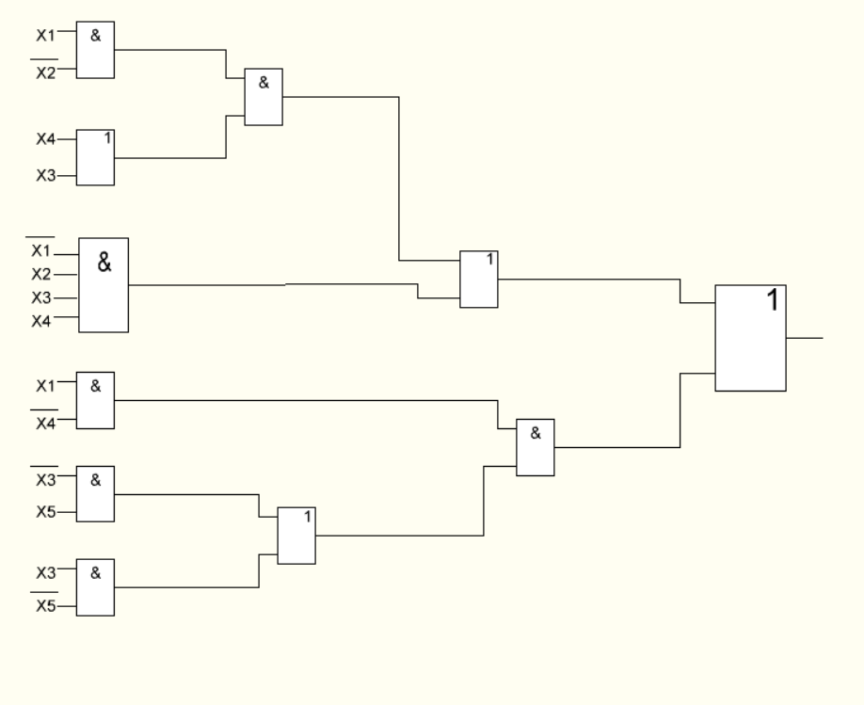

Задержка схемы T = 4τ; Цена схемы Sq = 21

Построение схемы в булевом базисе с однофазными входами:

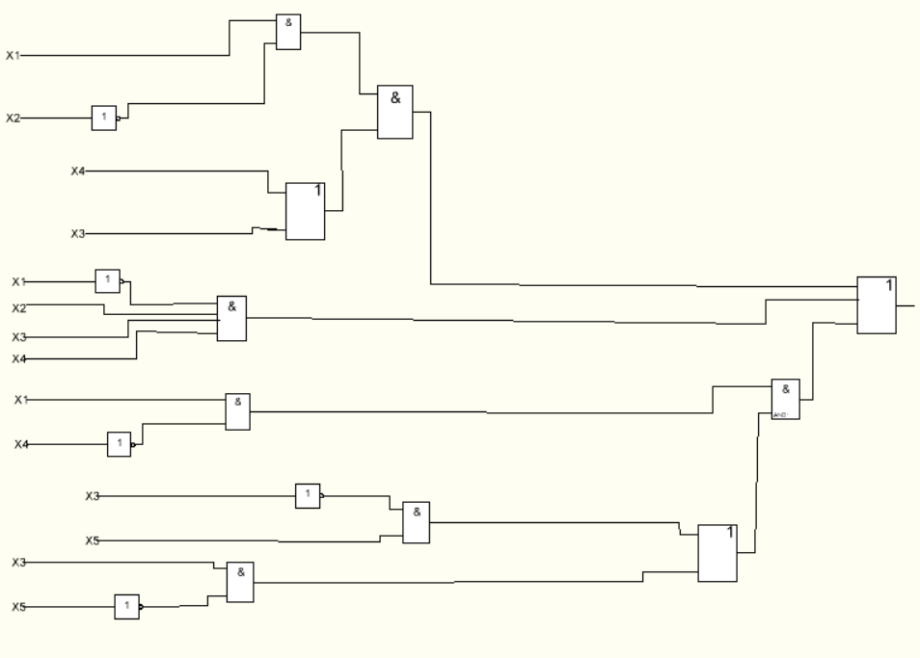

Задержка схемы T = 5τ; Цена схемы Sq = 20

7. Синтез комбинационных схем в универсальных базисах

Базис (ИЛИ-НЕ)

*=*

= ((x1↓x2) ↓ (x4↓x3)) ↓ ((x1↓x2) ↓ (x3↓x4)) ↓ (((x3↓x5)) ↓ (x3↓x5)) ↓ (x1↓x4))

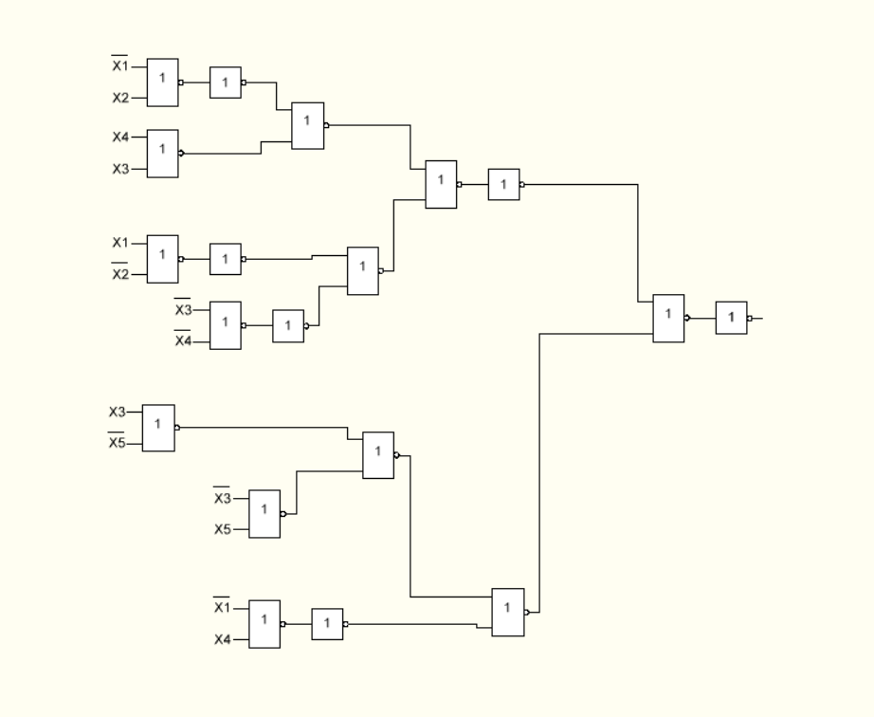

Задержка схемы T = 7τ; Цена схемы Sq = 29

Преобразование схемы из булева базиса в универсальный

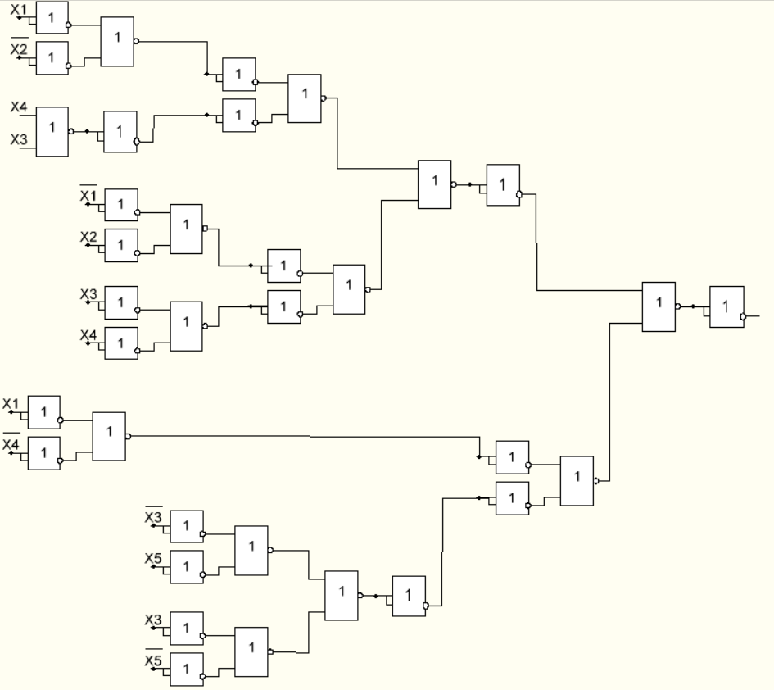

Базис (И-НЕ)

*=*

f = ((x1 | x2) | (x4 | x3)) | ((x1 | x2) | (x3 | x4)) | ((x1 | x4)) | ((x3 | x5) | (x3 | x5)))

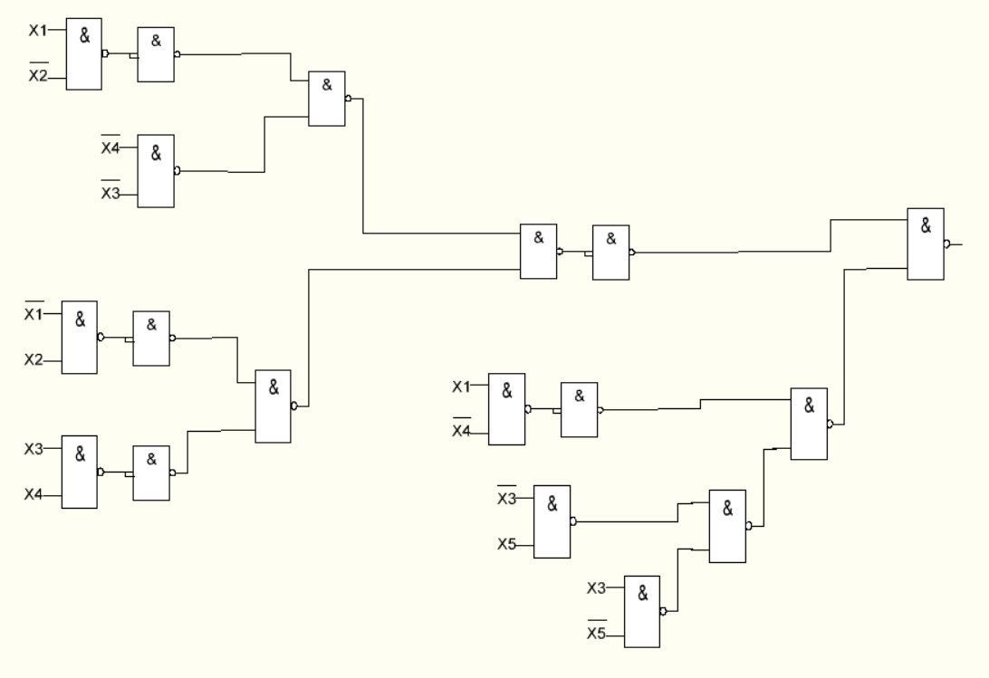

Задержка схемы T = 6τ; Цена схемы Sq = 28

Преобразование схемы из булева базиса в универсальный:

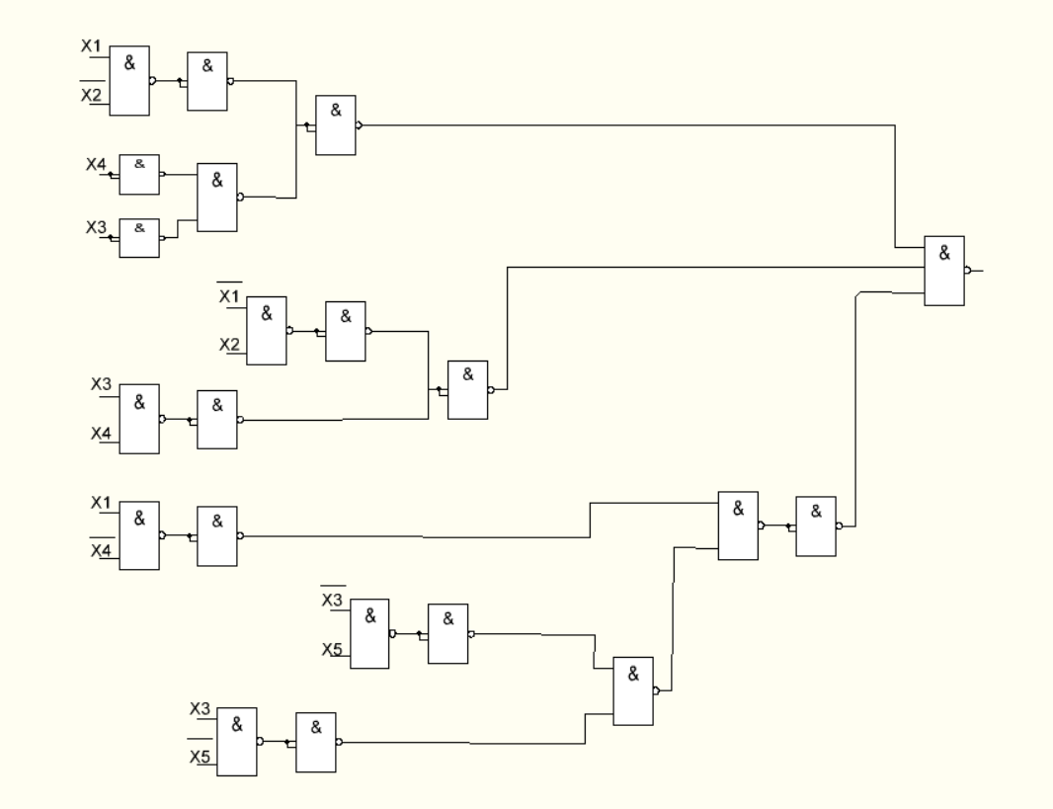

8. Синтез комбинационных схем в сокращенных булевых базисах.

Построение схемы в сокращенном базисе ИЛИ-НЕ:

(x1 v x2) v (x4 v x3) v (x1 v x2 v x3 v x4) v ((x1 v x4) v (x3 v x5 v x3 v x5))

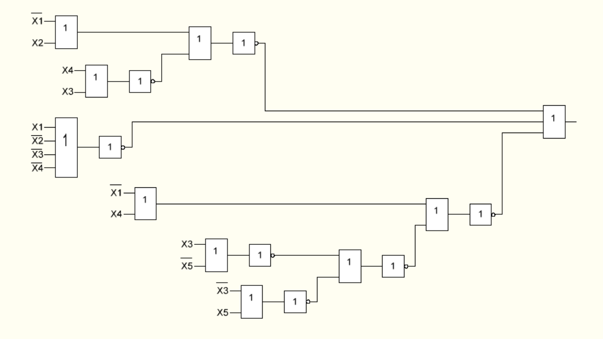

Задержка схемы T = 7τ; Цена схемы Sq = 27

Построение схемы в сокращенном базисе И-НЕ:

f = x1*x2*(x4*x3) * (x1*x2*x3*x4) * (x1*x4*(x3*x5*x3*x5))

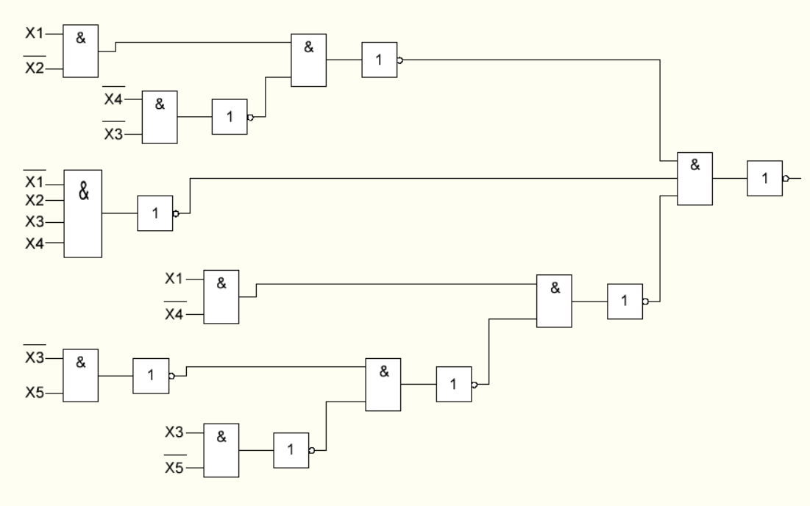

Задержка схемы T = 8τ; Цена схемы Sq = 28